 | CHAROTAR UNIVERSITY OF SCIENCE & TECHNOLOGY  DEVANG PATEL INSTITUTE OF ADVANCE TECHNOLOGY AND RESEARCH | 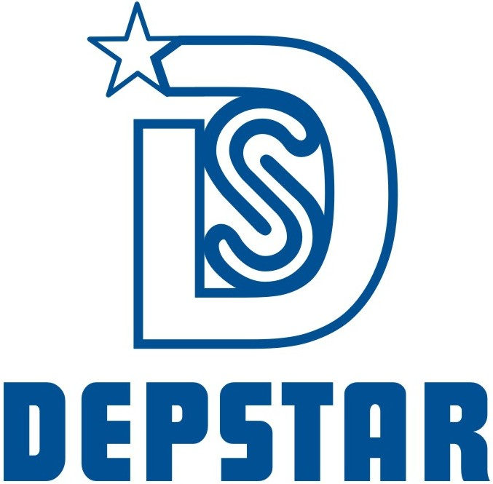

Weekly Report-2

Student ID:23DCS134 | Student Name:Venisha Thakker
From Date:12/05/2025 | To Date:16/05/2025
Semester:4th | Internship ID:

Work done in last week (Attach supporting Documents):

- Created Login/Register pages using React & Material UI (with dark theme).
- Set up route protection based on roles using JWT.
- Created base layouts for:
- User Dashboard: Booking page, active/past rides.
- Driver Dashboard: Ride requests and status management.
- Admin Dashboard: User, driver, and booking overview.
- Styled the UI with Material UI including dark mode support.
- Implemented React Router and created basic route structures for user and driver pages.

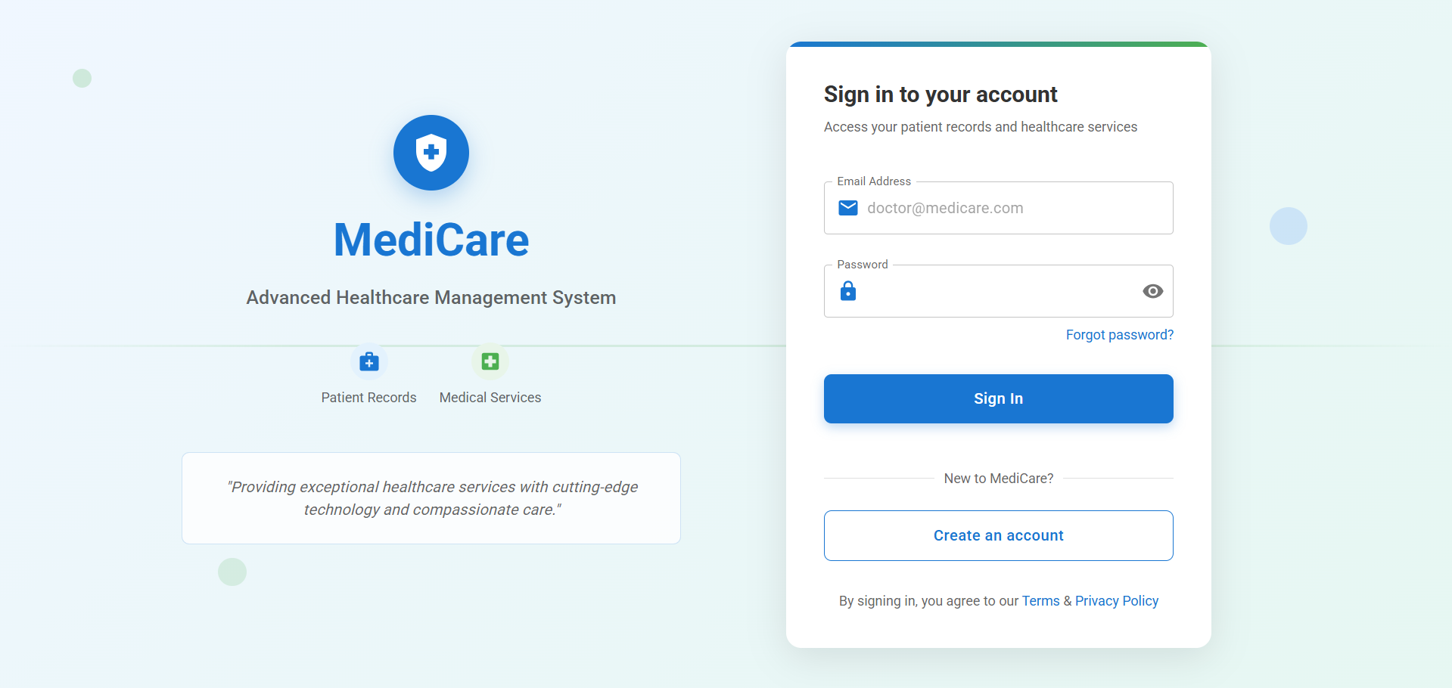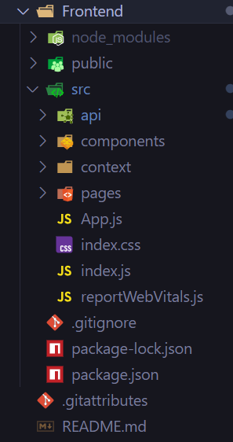
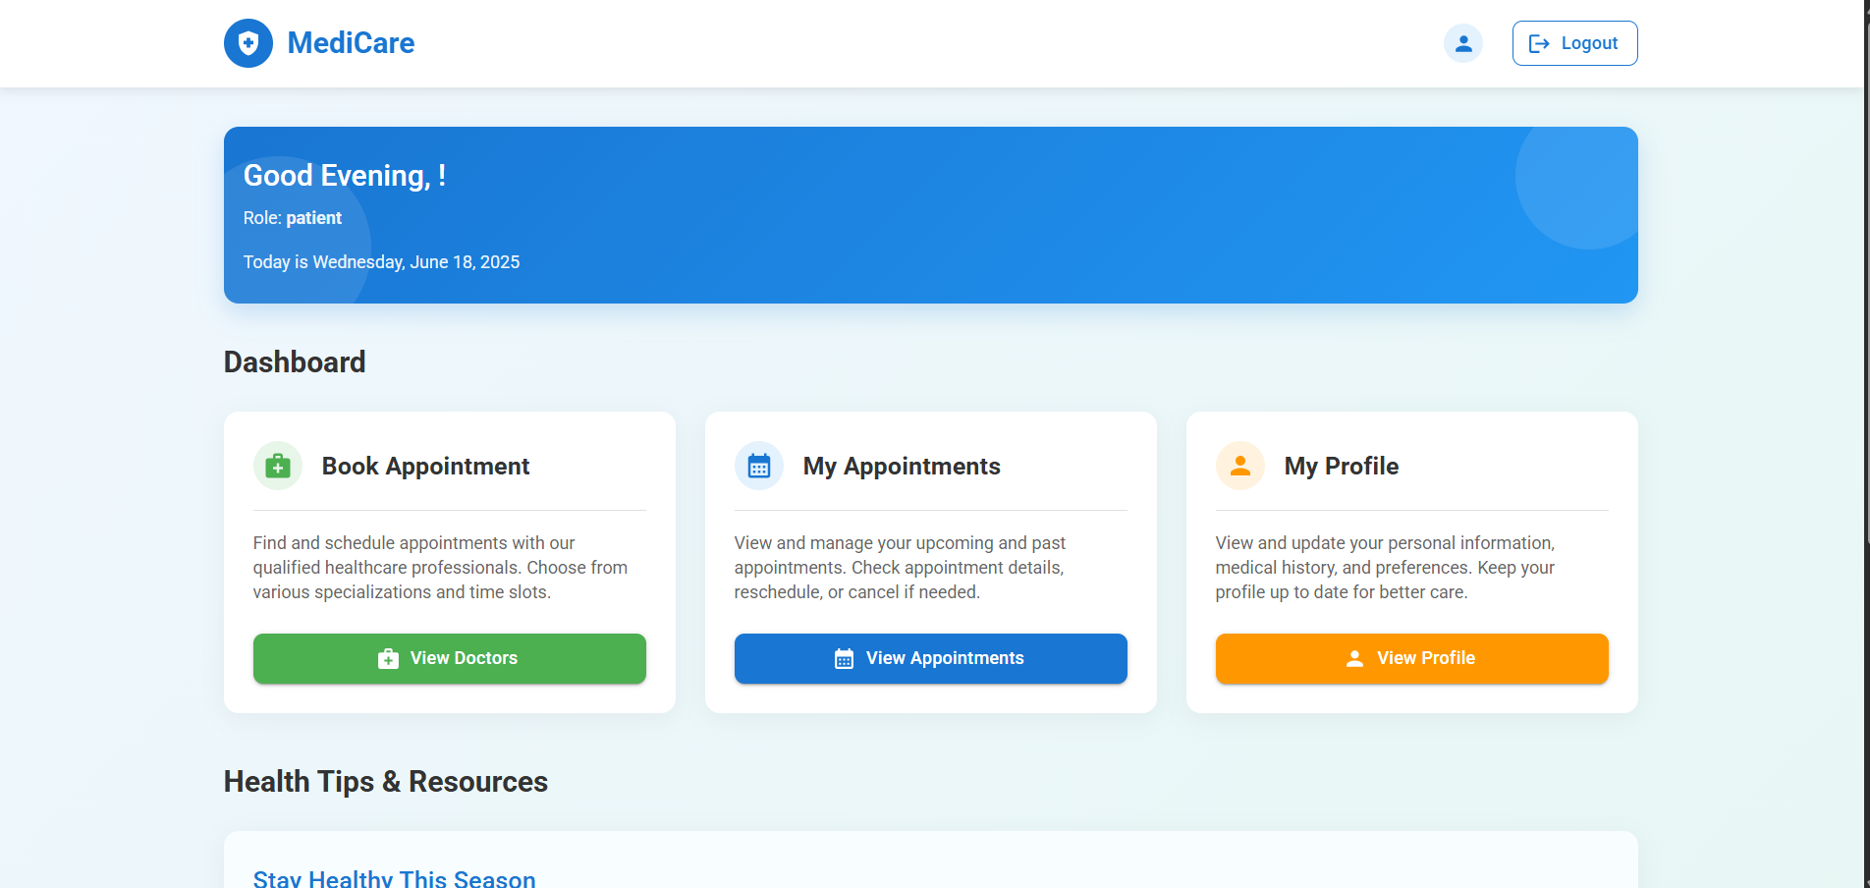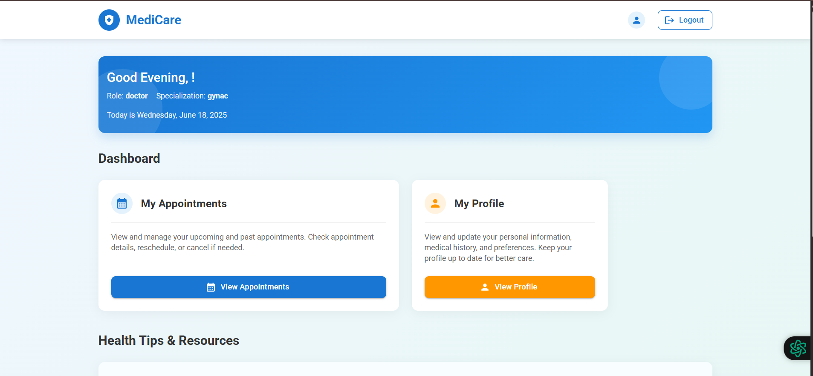
Plans for next week:

- Integrate Leaflet.js for map-based location selection
- Implement booking form with pickup/drop and cab type
- Add fare calculation logic

References:

- React.js official documentation – https://react.dev
- React Router: https://reactrouter.com
- JWT for authentication and authorization

Signature of External Guide Signature of Internal Guide

